2016 Elections Coverage Website

System Requirements

Team One

John O’Kelly, Owen Morrissey, Steve Lesicka, Chris Kobierowski

**2016 Elections Coverage and Reporting Platform**

*Functional Requirements*

This system is proposed to be a robust content publishing and discussion platform for the CCSU Journalism Department. The main focus of this application is to provide coverage for the news pertaining to local, state, and federal governments, especially for the upcoming elections. The system’s content publishing and management platform should be able to handle text, images, audio, and video files presented in rich text. Content publishers and administrators will be able to post stories, information, and forum topics containing any combination of the above media types. Unregistered users will be able to create accounts and discuss topics in a forum to join the discussion. In addition, a map should be available with the ability for an administrator to designate points on the map that link with stories. Administrators will be able moderate user and content publishers submissions, meaning deletion, editing or other modifications. Administrators will be able to view analytics regarding the website and articles. Analytics should include but not be limited to demographics and page views, most likely provided using google analytics.

*UML Use Case Diagram*

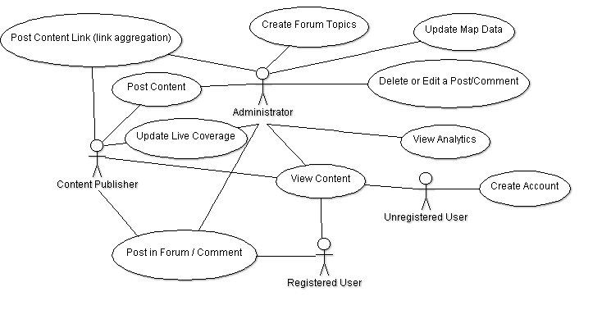

|  |
| --- |
| *Use Cases*  1. Post Content Link User Role: Content Publisher Goal: To post a link to an article hosted on a 3rd party website. Reason: To provide users with content relevant to the elections and local news. Pre-Conditions: Content publisher is logged in, an article has been found, and a link is available to the content.  Post-Conditions: The link is posted to the website and available for users to view. |
| 2. Post Content – ***Breakdown Candidate*** User Role: Administrator, Content Publisher Goal: To post content for all users to view. Reason: To provide users with well-presented media for consumption. Pre-Conditions: Content publisher or administrator is logged in, and has content to post. Post-Conditions: The content is posted and is available for viewing. |
| 3. Update Live Coverage –***Breakdown Candidate*** User Role: Administrator Goal: To post real-time updates of the electoral process. Reason: So users can enjoy and stay informed with up-to-the-minute updates.  Pre-Conditions: Account with administrator permissions is logged in. Post-Conditions: The update is pushed out live to all viewers on page. |
| 4. Post in Forum/Comment – ***Breakdown Candidate*** User Role: Registered User, Content Publisher, Administrator Goal: To allow a user to reply to a discussion topic or content post. Reason: To provide user-generated content and discussion. Pre-Conditions: Account with above registered user permission is logged in. Post-Conditions: The discussion post is added to the relevant media. |
| 5. Create Forum Topic User Role: Administrator Goal: Create a new topic. Reason: To provide a forum for users to post in. Pre-Conditions: There is not an identical forum topic. Post-Conditions: Users can now post content inside of the topic. |
| 6. View Content User Role: Administrator, Content Publisher, Registered User, Unregistered User  Goal: Allow all users to view content posted. Reason: To see content that other users have posted. Pre-Conditions: Content has been posted. Post-Conditions: Users can respond to post, Administrator can edit and delete posts. |
| 7. Create Account User Role: Unregistered User Goal: Allows user to create their own personal account. Reason: To allow users to join and contribute to the community. Pre-Conditions: User does not have an account. Post-Conditions: User now has access to privilege given to their user class. |
| 8. Update Map Data User Role: Administrator Goal: Designate points on map that link with stories. Reason: To provide users an easy way to view the location to which a story is connected. Pre-Conditions: A story has been posted. Post-Conditions: A point on the map is linked with the story. |
| 9. Delete or Edit Post/Comment – ***Breakdown Candidate*** User Role: Administrator Goal: Delete or edit submissions by users and content publishers. Reason: To provide the ability to moderate posts and comments in case inappropriate content is submitted. Pre-Conditions: A post/comment has been submitted and an administrator has a reason to edit or delete it. Post-Conditions: The post/comment has been changed or deleted. |
| 10. View Analytics User Role: Administrator Goal: View analytics about the website such as demographics and page views Reason: To give administrators meaningful statistics about the website. Pre-Conditions: Analytics have been collected and administrator is logged in. Post-Conditions: The administrator is able to view analytics. |

*Non-Functional Requirements*

**Product Requirements**

* User-friendly
* Concise, clear, clean interface
* Easily Maintainable – technologically and content-wise

**Organizational Requirements**

* Github is required
* Frequent commits for the ability to safely roll back code
* Forking to add major features
* Netbeans IDE to standardize configurations
* Java used as server-side language
* Frequent code review to ensure usable code
* JavaDB, Glassfish, Tomcat

**External Requirements**

* Server to host Glassfish, Tomcat, and DB (Not req. for dev)
* Domain (Provided by Journalism Dept.)

*Glossary*

**Unregistered User** – Any visitor to the website that is not signed in to any account

**Registered User –** Content Publishers and Administrators are also registered users, however this is the standard account with the lowest permission set.

**Content Publisher –** User account with elevated permissions to allow the posting of content.

**Administrator –** User account with highest permissions. Ability to delete, modify, and create content across the entire platform.

**Content –** Any combination of text, graphics, or audio posted for viewing on the site.

**Map –** A birds-eye view of geographical areas relevant to the news story.